Project Title: Visualizing US Natural Disaster Declarations: Trends and Patterns Student

Vijay S
Table of Contents
Section | Content Description | Page No
1 | Project Description | 1
2 | Dataset Used | 1
3 | Data Validation & Setup | 2
4 | Temporal Trend Analysis | 2
4.1 | Yearly Trend And Rolling Average | 2
4.2 | Disaster Type Evolution | 3
5 | Seasonality & Decade Analysis | 4
5.1 | Monthly Distribution | 4
5.2 | Decade-Wise Totals | 5
6 | Conclusion | 5

- PROJECT DESCRIPTION
The Temporal Trend Analysis milestone is a core component of the "US Natural Disaster Declarations: Visual Analytics" project. The primary goal of this phase is to evaluate the historical progression of disaster declarations from 1953 to the present. By leveraging Python-based visual analytics, this study aims to uncover long-term climate trends, identify peak disaster years, and understand the recurring seasonal patterns that influence emergency management across the United States.

2.0 DATASET USED
The analysis utilizes the cleaned FEMA Disaster Declarations dataset.
- Scope: 1953 – Present.
- Source: data/processed/fema_clean.csv.
- Key Features: Declaration Date, Incident Type, Year, and Month.

Feature Name | Description | Importance
Declaration Date | The official date when the disaster was declared. | Used for time-series conversion.
Incident Type | Category of the disaster (e.g., Fire, Flood, Storm). | Used for trend comparison.
Year | Extracted year from the declaration date. | Used for annual trend analysis.
Month | Extracted month from the declaration date. | Used for seasonality detection.

3. DATA VALIDATION & SETUP
Before performing the analysis, the environment was configured with necessary libraries like pandas, seaborn, and matplotlib. The 'Declaration Date' column was parsed into a standard datetime format to ensure accurate temporal grouping.

4. TEMPORAL TREND ANALYSIS

4.1 Yearly Trend and Rolling Average
We analyzed the total annual declarations to identify growth patterns over the decades. A 5-year rolling average was applied to smooth out short-term fluctuations.
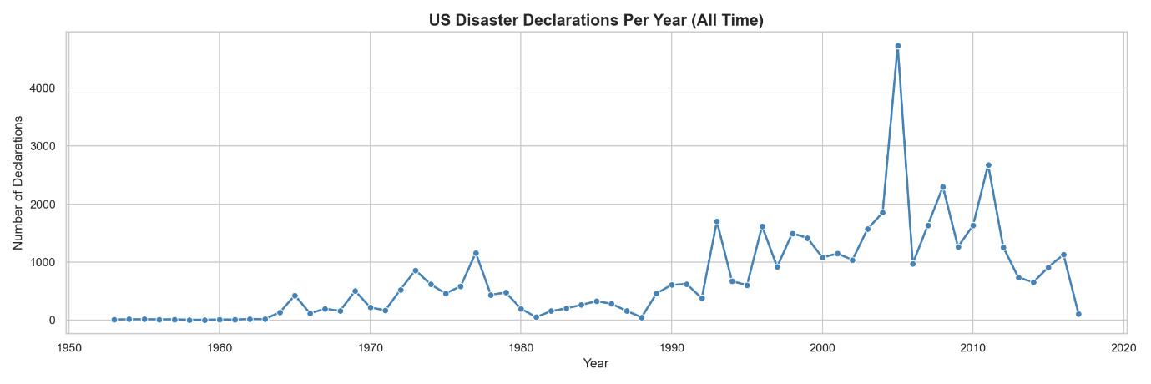
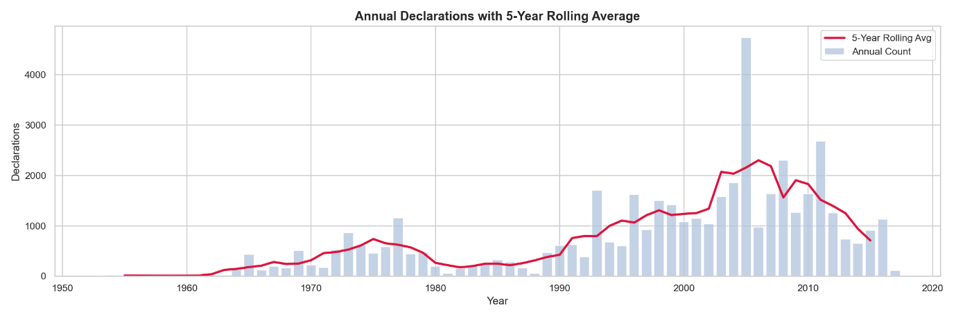
- Insight: The analysis shows a significant upward trajectory in disaster frequency. The rolling average confirms that the baseline for disasters in the US has moved higher over the last 20 years.

4.2 Disaster Type Evolution
This section compares how different types of natural disasters (Storms, Floods, Fires) have changed in volume over time.

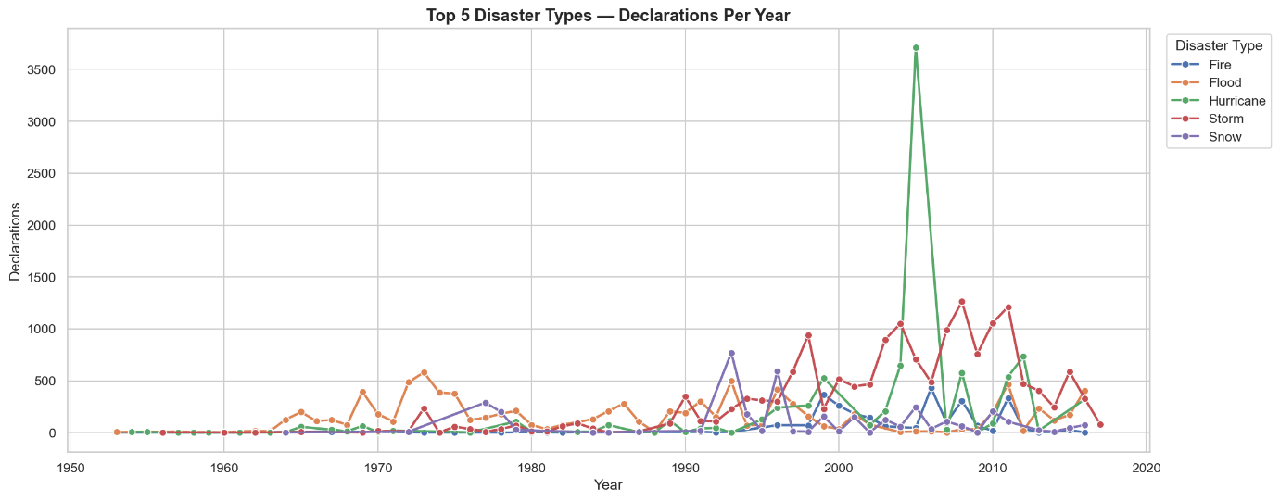

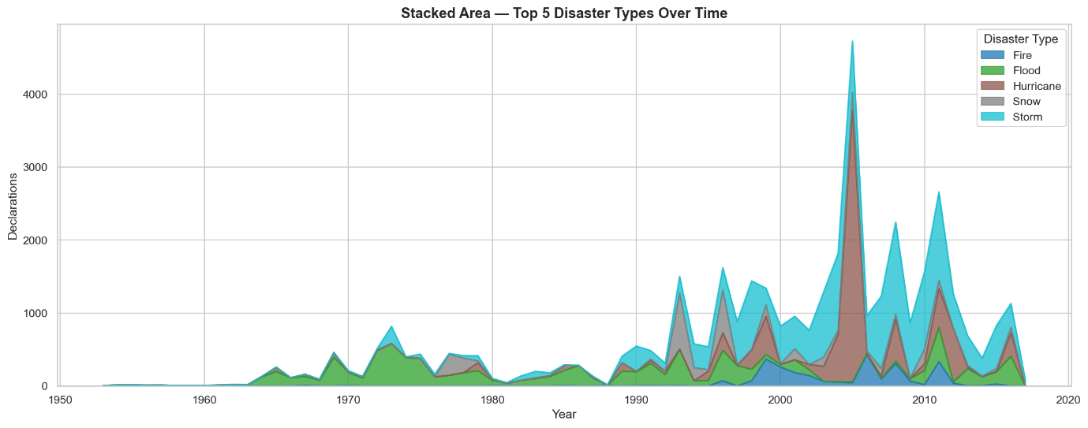

- Insight: While Severe Storms remain frequent, Fire declarations have shown a disproportionate increase in the recent decade, indicating a shift in environmental risk factors.

5. SEASONALITY & DECADE ANALYSIS
5.1 Monthly Distribution
Disasters were grouped by month to detect recurring seasonal cycles throughout the year.

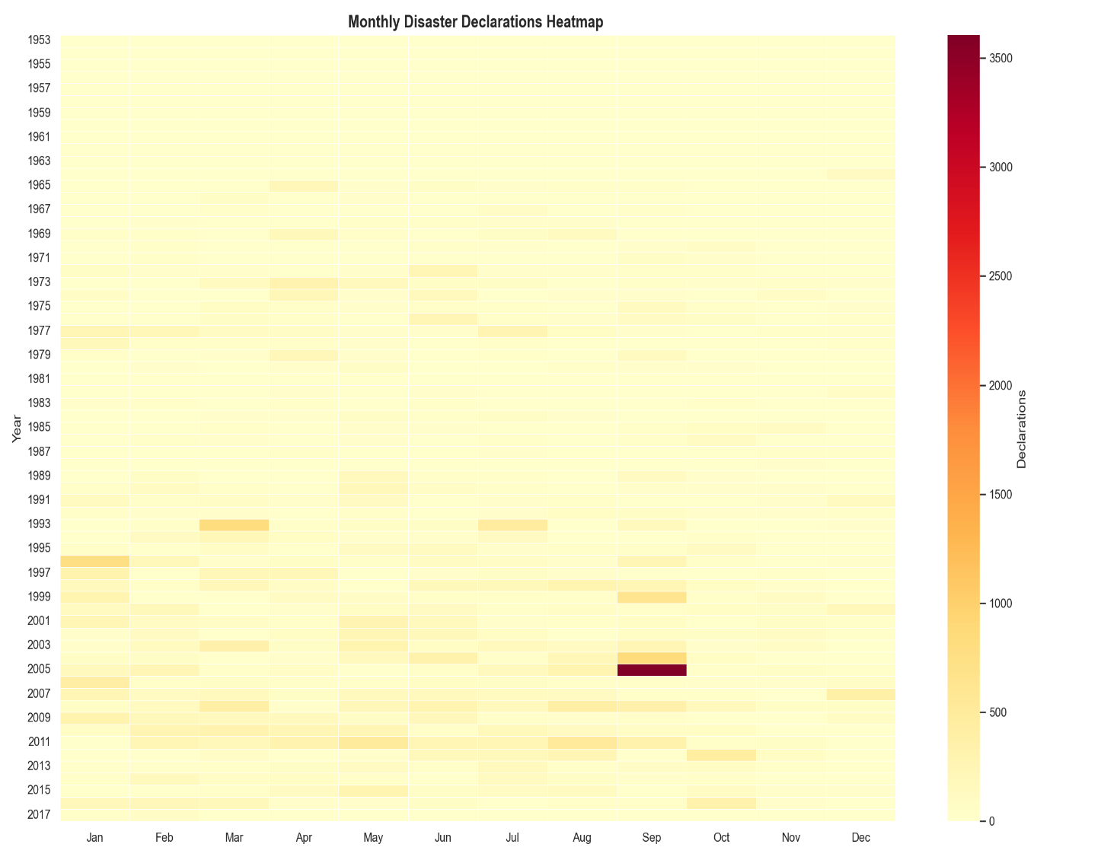

- Insight: A clear bi-modal seasonality is observed. Disasters peak during the Spring months (Severe Storm season) and again in late Summer (Hurricane season).

5.2 Decade-wise Totals
To understand the scale of increase, declarations were summed by decade.
[Insert Chart: decade_analysis.png here]
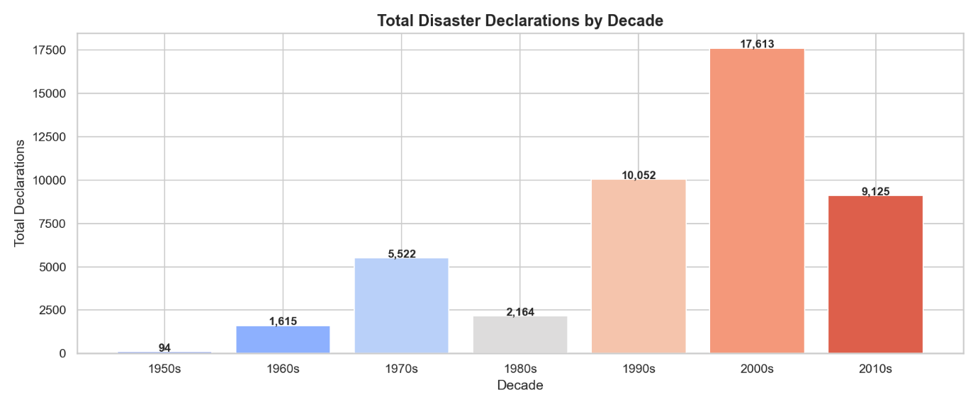
- Insight: Every subsequent decade since the 1950s has seen a rise in declarations, with the most recent decade showing the most dramatic volume of federal activity.

6. CONCLUSION
The temporal analysis of the FEMA dataset was completed successfully. The findings confirm that disaster declarations in the US are not only increasing in total volume but are also becoming more volatile.

